BSCS - 2021
Muhammad USAMA BIN AZAM

EDUCATION & QUALIFICATION
University of Sargodha 2017-2021
BSCS
CGPA 2.43

Punjab College shorkot
2017
ICS (physics)
Subjects: Mathematics, Physics, Computer

Govt. High SCHOOL Shorkot 2015
Matriculation (Science)

PROJECTS
Research Project
Mobile phone E-commerce website
Object Oriented Analysis and Design
Design document of Hospital Management System
Database Systems
Library Management System
Design and Analysis of Algorithms
Graph Coloring
Multi-Media
Media Player, Audio converter
ACTIVITIES, HONORS, & AWARDS
No activity

SKILLS & TOOLS
Tools: Android studio, Visual Studio,
Microsoft Office , Audacity,
Microsoft Visual, Eclipse, ,MS Visio Pro ,Video-Scribe
Skills: C++,HTML,JAVA

INTERESTS
Reading, Cricket Analysis, Video Editing, Graphics Designing

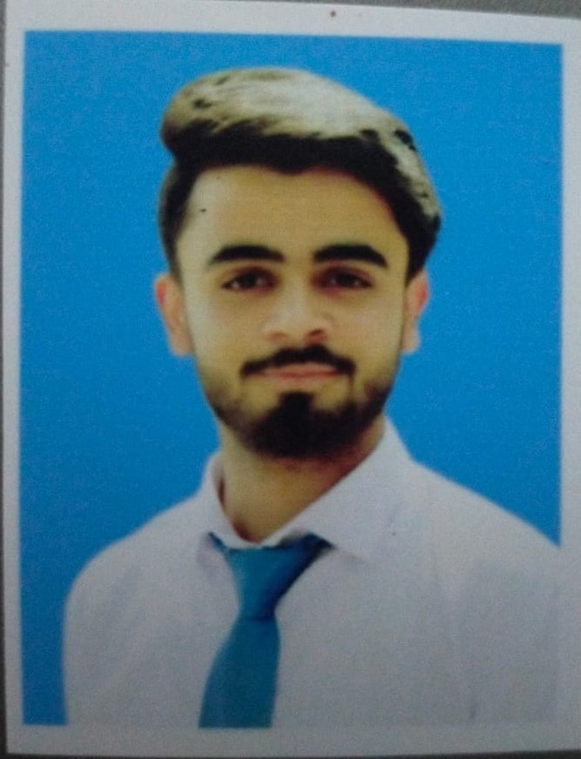

Date of Birth

27/01/1999
Business Address CS & IT Department
University of Sargodha University Road, Sargodha, Pakistan
Cell-Phone: 03174664360
Email: Uxamakhan27192@gmail..com

